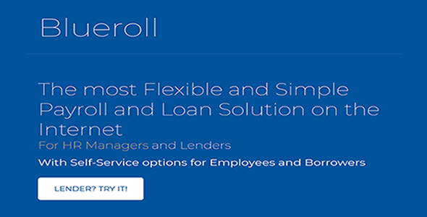

**Product Name**

Blueroll Payroll and Loan Management System

**Description**

A web application built to manage all Payroll activities from configuration to disbursement, manage Loan sourcing and engagement activities.

Loan Managers can bring their old and new Loans to Blueroll for management. Loan application workflow is fully supported from borrower interest to Loan Agreement signing.

**Limitations**

This application does not transfer funds into borrowers bank account

This application does not transfer salary payment to employee account.

**Design Details**

This application was developed using HTML/CSS/Javascript front end, PHP as the server side script and Mysql as the database.

The design is simple

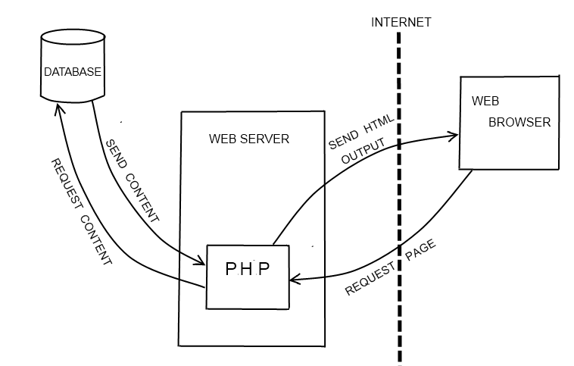

**Process View**

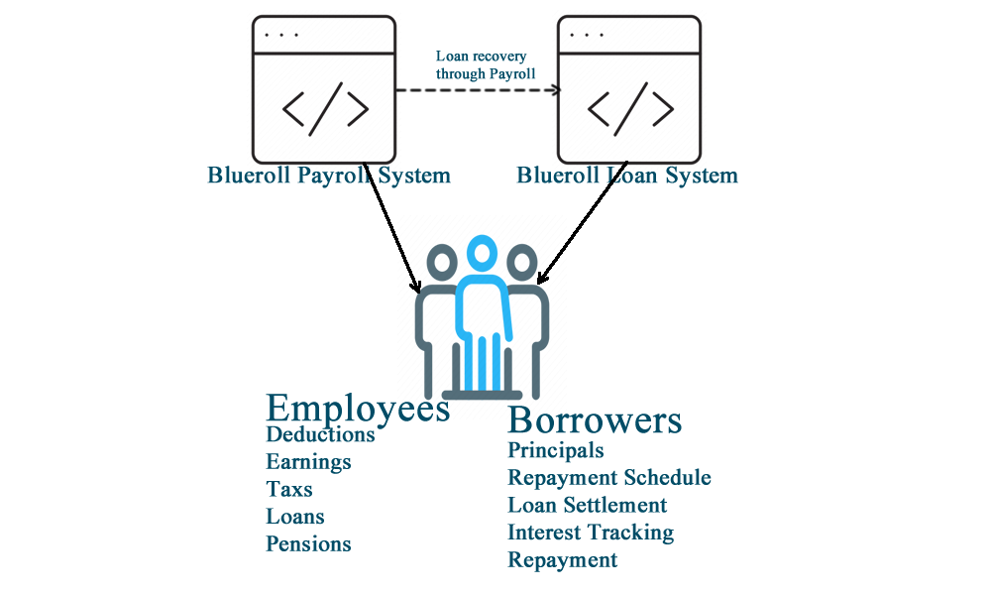

**External Sources**

Requires SMTP Server for Email

**Application Structure**

**Blueroll** --- App folder

**----app** (HTML/PHP application front end)

**-------controller** (Application logic/backend)

**----assets** (styles)

**----CSS** (styles)

**Deployment**

**Server installation**

**Requirement**

1. PHP version 5.3.4, 5, 5.5.12, 5.5.x
2. MSQL Database
3. Storage Solutions for storing files (Optional)

* Step 1: Copy the app folder to your website root (You can also install it in a folder).
* Step 2: Unzip the app.
* Step 3: Point your browser to your domain. I.e. [www.yourdomain.com/appfolder](http://www.yourdomain.com/appfolder). E.g. <http://naijadailywork.com/blueroll/>
* Step 4: Point your browser to [www.yourdomain.com/blueroll/install](http://www.yourdomain.com/blueroll/install). E.g <http://naijadailywork.com/blueroll/install> **IMPORTANT**
* Step 5: Fill the Installation form and Click on “install”.
* Step 6: Before you click on “Click here to continue”, delete “Install” folder.

**Default User:**

Username: admin@blueroll.com

Password: 123456